**Jewish Tallinn**

The article about the history of Jews in Tallinn on the website of Estonian Jewish Museum ([link](https://muuseum.jewish.ee/Religion/Uus%20synag1_en.html))

**Points of interest on the map:**

The Estonian word “tänav” corresponds to street, “maantee” means road, and “puiestee” means boulevard.

Exists

No longer exists

Use has changed

**Prayer houses and synagogues**

**Jewish****cemeteries**

**Juudi haridus**

**Jewish Heritage**

**Jewish businesses** **(Shops on Viru tänav)**

**Other businesses**

**Holokausti mälestusmärgid, sh Tallinna ümbruses.**

# **Prayer houses and synagogues**

**4**

*Neugasse / Uus 37*

1867–1870

**The only 19th-century cantonists’ prayer house whose building has survived.**  Now the building houses the Kellerteater [Cellar Theatre] (2025). In 1867, the Tallinn War Council gave the former gunpowder cellar near the Small Coastal Gate as a prayer house for the Jewish cantonists. The Jews adapted the space to a suitable condition, for which they broke a doorway through the façade. The same building was also used as a Cheder (religious primary school).

**7**

*Wismari. Estimated location* ~1846–1862

**The first prayer house for Jewish soldiers, or cantonists, of the Russian Crown.**  The existence of the prayer house on this street is indicated in the City Government Register in 1846: namely, there was a Jewish prayer house near the Dombrücke bridge - this corresponds to the current Kaarli puiestee and the location can be more precisely attributed to Wismari tänav.

*Müürivahe 5* 1871–1875

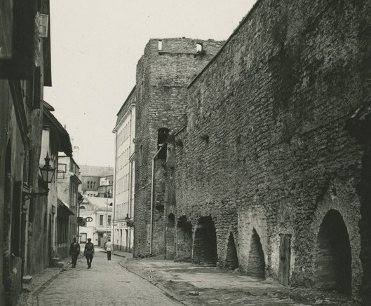

**9**

**Prayer house for merchants and craftsmen.** (marked with an arrow). Located in the two-storey Jakobsohn house. The building was hit during the bombing of March 1944 and was demolished after the war.

Photo: Tallinn City Museum

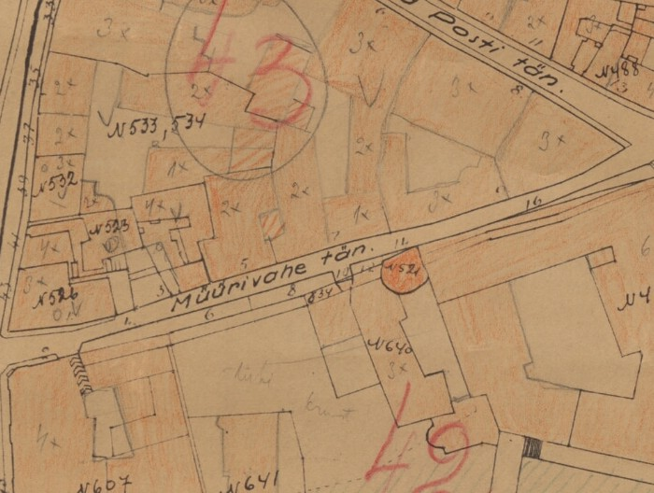

Map: ERA.T-6.3.1678; 1930 p 67

**25**

*Wallstrasse / Valli 6 (now Pärnu maantee 2)* 1880–1882

**The merchants’ and craftsmen's prayer house** was located on the 2nd floor of the building. The building partially covers the Hinke Tower of the Tallinn Fortress. Later, the building was used by the Geni printing house, and there was a flower shop on the first floor. In 2025, the building housed the Kuku café and club.

**32**

*Karu tänav 16* 2007 -

**Tallinn New Synagogue “Beit Bella”.**

The grand opening took place on 16.05.2007, which was Yom Yerushalaim – the Jerusalem Day in the Jewish calendar. It was the first synagogue built in the Republic of Estonia since the demolition of the Great Synagogue in 1947. The building was designed by the architects Andrus Kõressaar, Kaur Stöör and Tõnis Kimmel of the KOKO architectural firm. At the request of the main sponsor of the construction, Mr. Aleksander Bronshtein, the worship hall was named “Beit Bella” in honour of his deceased mother Bella Barski. The synagogue has a kosher (i.e. religiously compliant) dining room and the ritual pool, the mikveh. The Tallinn Synagogue is the only synagogue in Estonia. In 2007, the synagogue building received the title of the Best Concrete Building in Estonia and is among the 10 architecturally outstanding buildings in Tallinn.

*Karu 16* 2000–2007.

**33**

**Temporary Synagogue.**

Since the former prayer house building on Magdaleena tänav was in a state of disrepair in the late 1990s, the congregation moved to the 2nd floor of the Estonian Jewish Community Centre, where there was a temporary synagogue until the construction of a new building was completed. At the same time, in 2000, the Chief Rabbi of Estonia, Efraim Shmuel Kot, also arrived in Tallinn.

**34**

*Narva maantee 40 (currently 20).*

**Residence of Estonian Chief Rabbi Dr. Haim Aba Gomer and his family.** 1932–1941

Dr. Gomer was born in Belarus in 1894 into a rabbinical family. He studied at the Kaunas and Hrodna yeshivas (religious schools) and furthered his studies at the universities of Bonn and Cologne, where he received a doctorate in philosophy. He was elected the Chief Rabbi of Tallinn and Estonia in 1929. In 1931, he was granted Estonian citizenship, having learned the Estonian language by then. After the outbreak of war between Germany and the USSR, he turned down the opportunity to be evacuated to the rear because, as a rabbi, he considered it necessary to take care of his congregation. After the beginning of the Nazi occupation, he was taken out of his apartment onto the street, dressed as a clown and driven along Narva maantee, where onlookers mocked him and threw rocks and mud at him. Afterwards, he was taken to prison and later shot dead with his family probably at the Liiva cemetery.

**36**

*Schubbe / Kivisilla / Anveldi / V. Reimani 24* 1865–1867

**Cantonists' prayer house.**

The location is presumed because this part of the city was destroyed by the bombing of Tallinn on March 9, 1944.

**37**

*Väike Tartu maantee 8* 1871

**Cantonists' prayer house.**

Cantonists' prayer house. Located next to the future Great Choral Synagogue. This part of the city was destroyed by the bombing of March 1944 and street does not exist anymore.

*Maakri 5 / Väike-Tartu maantee 4*

**39**

**Prayer house in a wooden house** 1871–1883

**Tallinn Great Synagogue** 1885–1944

In July 1871, a wooden house with a garden was purchased for 2,500 rubles on the corner of Makeri (now Maakri) tänav and Kleine Dörptsche (Väike-Tartu maantee) tänav. In 1872, a ritual bathing pool, or mikveh, was opened. In 1883, the project for the synagogue by Nikolai Thamm Sr. was approved. The new building was completed in 1885 and remained the only synagogue in Tallinn until 1944, when the building was destroyed by the March bombing. The debris was demolished in 1947. The synagogue was located at the current intersection of Rävala puiestee and Laikmaa tänav.

Photo: Tallinn City Museum

**40**

*The corner of Rävala puiestee and Kuke tänav*

**Memorial plaque to the Tallinn Great Synagogue.**

Opened on January 10, 2019, at the corner of Maakri tänav, Rävala puiestee and Kuke tänav by the Tallinn City Centre District Government in cooperation with the Estonian Jewish Community and the Estonian Jewish Religious Community.

**41**

*Väike Arehna (Arefjevi, Ofenstrasse) / Lennuki 24* 1862–1865

**Cantonists' prayer house.**

Probably located in a house on a hill near the intersection of the current Lennuki and Liivalaia tänav (the hill was later levelled).

**42**

*Joachimstalerstrasse / Väike Juhkentali / Lennuki / Imanta 5* 1872–1873

**Prayer house for cantonists.**

Probably was located in a former gunpowder warehouse. The building has not survived.

Photo: Jaak Juske’s collection

*Kreutzwaldi 23* 1945–1966.

**44**

**The prayer house.**

Was located on the second floor of the Paulus Church Chancellery building, which was partly built on the site of the current Hilton Tallinn Park hotel. The construction of Paulus Church started in 1939, but due to the Soviet occupation and the war, only the basement floor and the chancellery double building remained completed, the 2nd floor of which was given to the reopened Jewish congregation. In 1966, the congregation had to leave due to the demolition of the building because of construction of the Kungla Hotel. The Kungla Hotel, in turn, was demolished at the beginning of the 21st century and the Hilton Tallinn Park Hotel was built on this location.

In Magdalena synagogue in 1986.
With the TU hat is Mikhail Dashkovsky, right from him - Edward Brailovsky. 
Photo: Kreitzwaldi tänav in 1937. Enn Nõu’s collection

**50**

*Magdaleena 9* 1966 – 21.12.2000.

**A former warehouse converted into a prayer house.**

Until the end of the 1980s, the congregation's gabbais (elders) also lived in this wooden house, who also fulfilled the duties of the rabbi and cantor. Currently, the house has been returned to its pre-war owner and is not in use and partially dilapidated.

Photos: on the right – inside prayer house in 1986

# **Jewish cemeteries**

**49**

*Magasini 27*

**Old Jewish Cemetery** 1784–1909. Demolished in1960s.

**Magasini Street Cemetery Park.** Opened on October 12, 2023

The first records of Jewish burials in this area date back to 1784. The cemetery was legalized only in 1844. In 1856, the cantonists built a limestone fence around the cemetery, parts of which are still visible today. In the autumn of 1910, a mausoleum designed by Tallinn architect Jacques Rosenbaum was erected on the grave of Eshijahu Levinovich (Lewinowitsch), a leader of the Tallinn Jewish community, and his wife. It was a token of gratitude for the successful leadership of the construction of the Tallinn Great Choral Synagogue. Tallinn Old Jewish Cemetery was closed for burial by decision of the then City Duma [Council] from October 1, 1910. This was demanded by neighbouring residents who were unhappy with the "malodorous miasma" emanating from the cemetery. The cemetery was in a marshy area and the abundant surface water made burial difficult. The last burial with a special permit took place in Tallinn Old Jewish cemetery in 1936. The cemetery remained intact even during the German occupation, but during the Soviet regime, the demolition of the cemetery began as early as the 1950s. By 1963, the mausoleum and chapel had also disappeared, and the burial area was finally destroyed in 1967, when a car depot began to be located there. After the collapse of the USSR, the cemetery area was left unmaintained. In 2020-2023, the City of Tallinn, through the City Centre District Government, in cooperation with the Estonian Jewish Museum, the Estonian Jewish Community and the Estonian Jewish Religious Community, carried out the renovation of the Old Jewish Cemetery, for which the Tallinn City Council allocated nearly a million euros. The boundaries of the burial area were determined, which is currently a green area that is not allowed to be walked on. Parts of the tombstones found during the renovation and construction of Reidi Road have been installed on the masonry that separates the burial area from the park area. The gates designed by Nikolai Thamm Sr. have also been restored. The cemetery park was opened on October 12, 2023. It is one of the unique parks in the capital.

[Exhibition](https://museum.jewish.ee/en/tallinn-old-jewish-cemetery/) in Estonian Jewish Museum.

The Tallinn Old Jewish cemetery on the [website](https://museum.jewish.ee/tallinna-vana-juudi-kalmistu/old-jewish-cemetery-in-tallinn/) of Estonian Jewish Museum.

Photo: colored black-white original.

*Rahumäe 5.*

**51**

**Rahumäe Jewish Cemetery.** 1910 – …

This is the only functioning Jewish cemetery in the city of Tallinn. The oldest tombstone dates to June 1911. The cemetery has a chapel building designed by architect Karl Burman in the 1910s, which is included in the National Register of Cultural Monuments. The chapel building is connected to the cemetery guard's house. Next to the chapel is a building for ritual washing of the deceased, or beit-tahor, and a shed. In 1922, wrought iron gates were made. In 1971, the Jews of Tallinn built a memorial monument to the Jews murdered in the Holocaust inside the cemetery without the permission of the authorities, which was one of the first in the USSR. In 2005, the memorial monument was relocated to the main square of the cemetery, where a memorial rally is held annually on International Holocaust Remembrance Day on January 27. A memorial to the deported Jews who perished was opened on the same square on June 14, 2011. Famous cultural and scientific figures, Jewish lawyers, and business figures of pre-war Estonia are buried in the cemetery. Visiting the cemetery is not permitted on Jewish holidays and during the Sabbath.

Photos: left – chapel building; right – the oldest surviving grave marker (Zalman Straž, buried on 3(16) June 1911).

# **Jewish education**

**40**

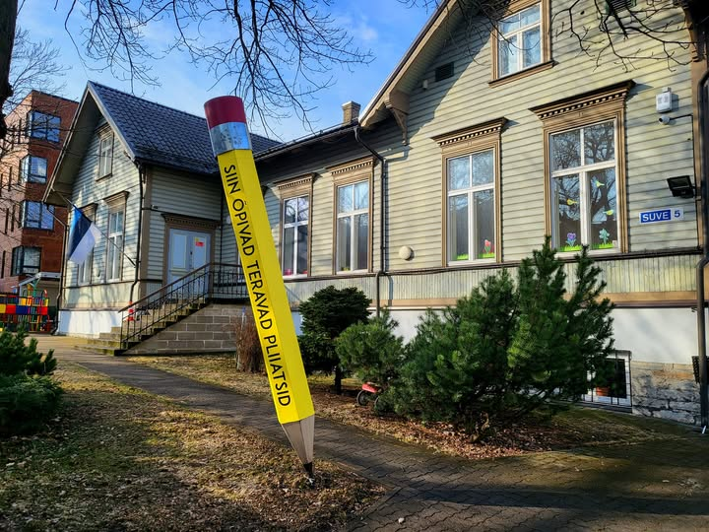*Suve 5*

**Jewish private kindergarten “Aviv”.** 2013 – …

In 2013, the private kindergarten “Aviv” (“Spring” in Hebrew) was opened on Suve tänav in the building acquired and renovated by the Estonian Jewish Community. The kindergarten uses Estonian as a basic language. Teaching is also conducted in Russian and Hebrew. Children are offered kosher meals. Since 2025, the kindergarten has been part of the Väike Päike Lasteklubi MTÜ network. The Jewish Education Center of the Tallinn Synagogue takes care of the preservation and development of the Jewish curriculum, traditions, holidays, and educational programs.

*Vana-Viru 15*

**27**

**Private Elementary School (Yiddish).** 1928–1933

In the late 1920s, tensions grew within the Jewish community of Tallinn due to disagreements over the language of instruction at the Jewish Secondary School. Some parents believed that the language of European Jews, Yiddish, should be used. Others, mainly supporters of Zionism, insisted that Hebrew education should be implemented because it would help with resettlement to Palestine. The disputes, which were called the language war, were so heated that some dissatisfied parents decided to establish a Yiddish-language elementary school. When Samuel Gurin, the Head of the Secondary School, found a compromise solution by dividing the school classes in half – Hebrew and Yiddish – the private elementary school was closed, apparently due to the lack of students.

**28**

*Karu 16*

**Jewish Private Secondary School (Gymnasium)** 1924–1940

**Tallinn Jewish School** 1990 – …

The largest Jewish educational institution in Estonia. The building was designed by the Baltic German architect Erich Jacoby. Construction lasted 1.5 years. On February 3, 1924, the building was ceremonially opened with the participation of Konstantin Päts, the State Elder of Estonia. The cultural autonomy of Estonian Jews was proclaimed in the school auditorium. After the beginning of the Soviet occupation, the building was nationalized, and the secondary school was reorganized into a public school (13th secondary school). During the German occupation, the school building was used as a hospital for German soldiers. After the war, the Jewish school was not restored. Technical School No. 1, and later the Maritime School operated here. In the 1970s, the building's unique façade was destroyed when an extension was built. In 1990, the property was returned to the Tallinn Jewish congregation (now the Estonian Jewish Religious Community) as illegally expropriated property, and the general education Tallinn Jewish School (municipal school) was opened in the building. After renovation, the extension houses the Estonian Jewish Community Centre (since 1998) and the Estonian Jewish Museum (opened in 2008). The Tallinn Synagogue was opened in the eastern part of the property on 16.05.2007.

Photo: Tallinn City Archives

**35**

*Raua 16.*

**Private Jewish Elementary School** 1880–1924

A group of educated Jewish youth (Rebekka Lopatnikov, Isak Ortman, Yette Israelson) established an elementary school for Jewish children, which was called *Elementarschule für Jüdische Kinder.* The school ceased its activities after the opening of the Tallinn Jewish Secondary School.

**38**

*Maakri 5.*

**Elementary School “Cheder”, Private Secondary School (Gymnasium)** 1904–1924

A Jewish elementary school, or cheder in Hebrew, initially operated in an extension to the Great Synagogue, but at the request of parents, the teaching of secular subjects was also increased in 1919, which led to the establishment of a private secondary school in 1923, but already at the beginning of the following year the secondary school moved to a newly completed building on Karu tänav. The building was damaged in the March bombing of 1944, and in 1947 it was demolished together with the ruins of the synagogue.

*Pae 50a, P.Süda 3*

**46**

**Jewish groups in various kindergartens in Nõmme, Mustamäe and City Centre districts** 1989–2013

The first group for Jewish children was opened in a kindergarten in Nõmme. Later, the group worked in various places until the opening of a private kindergarten on Suve tänav.

# **Jewish Heritage**

**5**

*Olevimägi 14/ Vene 35/37*

**Reception Room of the Estonian Jewish Cultural Society** 1988–1990

For the first 1.5 years of its activity, the Estonian Jewish Cultural Society used the premises of the Estonian Cultural Foundation. Once a week, on Thursdays, the society's board has held a reception there, providing information and distributing memorabilia.

**10**

*Väike-Karja 10/12*

**The founding of the Estonian Jewish Cultural Society.**

On March 30, 1988, the Estonian Jewish Cultural Society (EJKS) was founded in the small auditorium of the Ministry of Culture of the Estonian SSR. Eighty-five people attended the meeting. Samuel Lazikin was elected as the chairman of the society. Initially, the society operated under the Estonian Heritage Society. The EJKS was the first legal, free Jewish cultural association in the Soviet Union.

**11**

*Väike-Karja 1–3*

**Jewish Social Society** 1918–1940

**Sholem Aleichem Jewish Workers' House** 1940–1941

The Social Society played a significant role in organizing the social life of Tallinn's Jews. On the second floor of the building located at the corner of Väike-Karja and Sauna streets were quite spacious rooms. In addition to a hall and offices, there was a buffet that served delicious kosher dishes of Jewish national cuisine. The society's hall was also permitted for use by others, which brought additional income to the society's treasury. With the establishment of the Soviet regime, all institutions of the Jewish Cultural Autonomy were liquidated, and the society's premises were given to the Sholem Aleichem Jewish Workers' House, established by the Communist Party, whose task was ideological work among the Jews of Tallinn. The building and some of the adjacent houses belonged to the Gutkin and Sundelevich families, who were textile and clothing merchants. In 1912, they planned a grand reconstruction in the block between Väike-Karja, Sauna, and Viru streets, which would have resulted by the first department store with an atrium in Tallinn, along with restaurants and a concert hall. However, World War I did not allow the project to be realized.

**29**

*Karu tänav 16*

**Center of the Estonian Jewish Cultural Society** 1990–1992

**Center of the Estonian Jewish Community** 1992–1998

After the opening of the Tallinn Jewish School, which the Estonian Jewish Cultural Society helped to establish, the school's administration allowed the society, and from 1992 onwards the community, to use the school's premises for their activities.

*Karu tänav 16*

**30**

**Estonian Jewish Community Centre.** 1998 – …

1972. aastal ehitati endises Tallinna Juudi Eragümnaasiumi hoones tegutsenud merekooli kahekorruseline juurdeehitus. Eesti Juudi Kogukond ostis juurdeehituse välja ja renoveeris neljakorruseliseks hooneks, kus asub praegu Kogukonna keskus. Hoones asuvad Eesti Juudi Kogukonna kontor, eri osakonnad (sotsiaalkeskus, noorte programmid, raamatukogu), õppeklass ja saalid ning Eesti Juudi Muuseum.

**31**

*Karu tänav 16*

**Estonian Jewish Museum.** 2008 – …

The Estonian Jewish Museum opened on December 17, 2008. The Museum is located on the 3rd floor of the Community Centre. Pre-registered visitors are offered guided tours of the Museum and the Tallinn Synagogue in Estonian, English, Russian and Ukrainian.

The website of the museum <https://museum.jewish.ee/en/>

# **Jewish Businesses**

The businesses on Viru Street operated until nationalization in 1940.

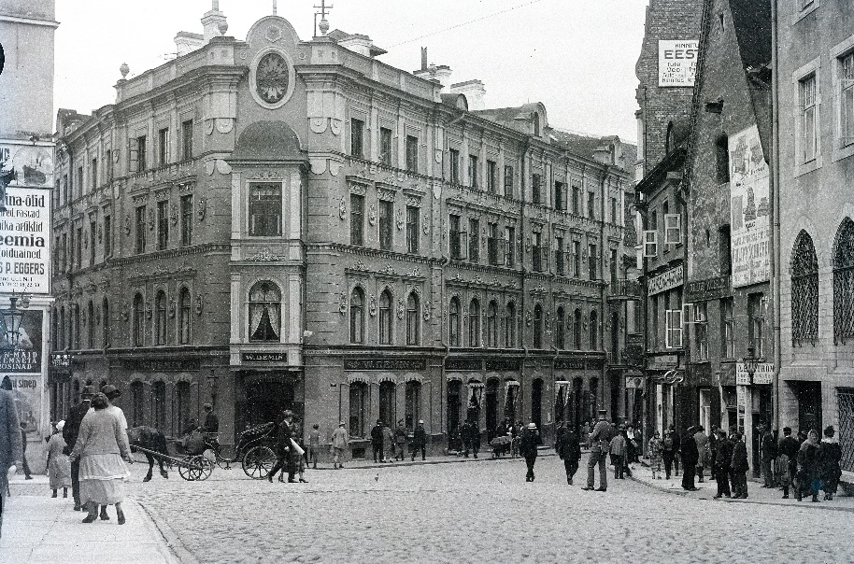

**13**

*Viru 1*

**Solomon Epstein's clothing store "Jockey Club", Aron Feinstein's bookstore.**

Photo: Estonian History Museum

*Viru 3*

**14**

**Herman Gutkin's clothing store "Inglise Magasin”, formerly Leopold Biek paper products and stationery**

**15**

*Viru 4*

**Abramsons’ fur department store.**

*****Viru tänav 6*

**16**

**"E. Rubin" watch and goldsmith's shop.**

On the right in the picture (1930)

**17**

*Viru 5*

**Debora Rubanovich's ready-made clothing business**

**"Jankelson and Son" kitchen and household goods business.**

**18**

*Viru 10*

**"Ginovker" sweets and chocolate,**

**Salomon Falshtein's, later his son Leon Falštein's (AS Royal Film) cinema Royal Vio (1910), Skandia (1930, nationalized 1941), Pioneer (1947).**

**19**

*Viru 7*

**"A. Rubanovich and Son" clothing store.**

**20**

*Viru 14*

**H. Markovich's watch and goldsmith's shop.**

**21**

*Viru 20*

**K. Josselson's watch and silverware shop.**

**22**

*Viru 22*

**"ERPE" ready-made clothing shop (Rõbak, Pikarevich),**

**Isak Berkovich's clothing shop,**

**Herman Friedmann's English calve and manufactory business,**

**"Gentleman" H. Karschenstein's raincoat industry business and clothing shop,**

**H. Vassermann's goldsmith's shop.**

**23**

*Viru 17*

**Hirsch Grinstan's boot shop**

**24**

*Viru 24a*

**A.Pessin's ready-made clothing.**

**25**

*Viru 24*

**Herz Vassermann's goldsmith's shop,**

**Isak Berkovitsch's clothing store,**

**H. Karschenstein's raincoat manufacturing business and clothing store “Gentelman”.**

Photo: Estonian National Archives

# **Other businesses**

**3**

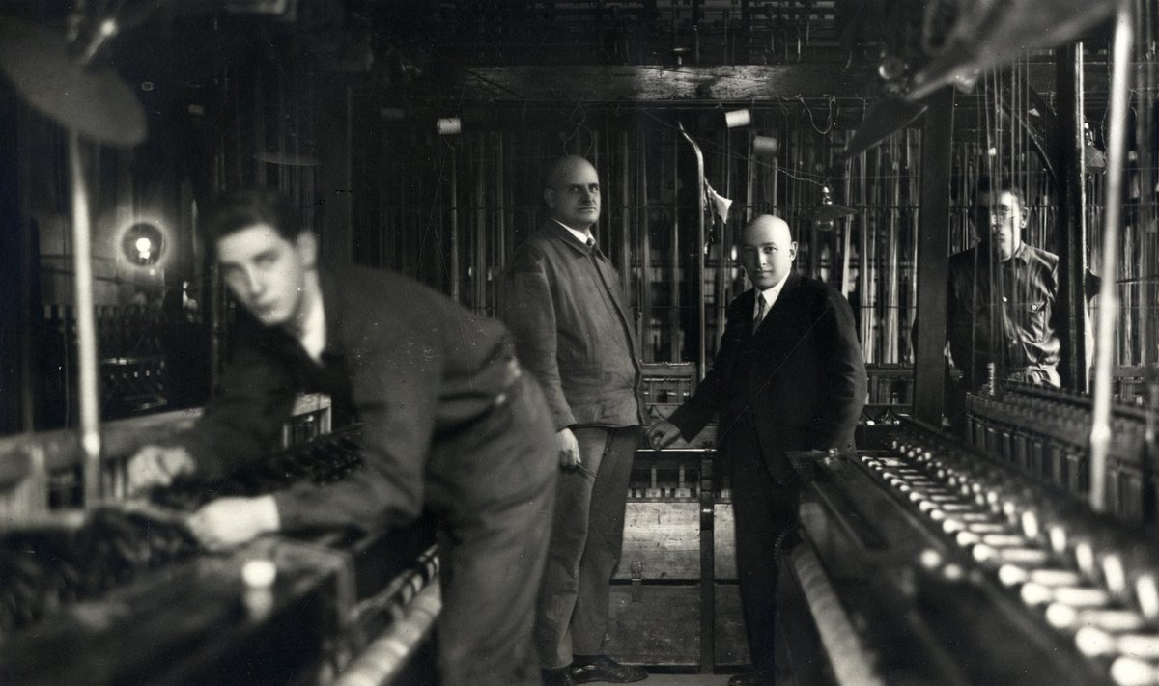*Põhja puiestee 7 / Kotzebue tänav 1* 1919–1940

**The building of Efraim Lerenmann's hosiery factory "Rauaniit".**

AS "Rauaniit" was one of the most successful businesses in Tallinn. After the start of the Soviet occupation, the nationalized "Rauaniit" became the factory "Punane Koit". Efraim Lerenmann died in the GULAG concentration camp in 1942, and his family lived in Siberia for a long time. After the war, "Punane Koit" was one of the largest hosiery and sock factories in the entire USSR. In 1991, the state-owned AS "Suva" was formed on its basis, which was privatized in 1993. When the production moved out of the building in 2014, the Estonian Academy of Arts bought the building, where it moved after renovation. E. Lerenmann's son Aron requested the restitution of the building, but only 10 years later and after his death did Aron's wife receive partial compensation.

Photo: AS “Rauaniit” owner Efraim Lerenmann (in a dark suit). Estonian National Archives

**8**

*Vabaduse plats 5* 1926–1940

**Leon Fallshtein's "Gloria Palace" cinema building.**

The luxurious cinema was built according to the design of the Latvian architect Frīdrihs Skujiņš. On the first floor was the Dancing-Palace Gloria dance hall, the interior of which was designed by the architect Aleksander Wladowski. The owner of the cinema was Leon Fallštein, who was deported with his family by the Soviet occupation authorities in 1941. Although he was allowed to return to Tallinn in 1944, he was deported again in 1949. In the years 1944 - 1948, the "Estonia" theatre operated in the building. In the years 1948 - 2005, the Estonian State Russian Drama Theatre operated in the building, which has been called the Russian Theatre since 2005. Since 2025 the theater has a new name Südalinna Theater. Leon Fallštein's father Salomon opened the first cinema in Tallinn, "Royal-Vio", at Viru tänav 10 in 1910, which from 1930, after reconstruction, was called "Skandia". The cinema was nationalized in 1941. In 1947, the "Pioneer" cinema operated there until its closure in the 1990s.

Photo: Estonian History Museum

*Vene 6* 1919–1940

**12**

**Tallinn Jewish Cooperative Bank.**

The bank was founded in 1922. It was partly helped by the financial support of the American Jewish Joint Distribution Committee, or "Joint", which was granted to Eastern European merchants and craftsmen to restore their businesses after the end of World War I. The bank served local businesses and Jewish individuals, and after the establishment of the Cultural Self-Government, its institutions as well. Initially, the bank was located at Viru tänav 7. In the early 1930s, the bank moved to Vene tänav 6, where it operated until its end in 1941. A large built-in safe has been preserved in the building.

**43**

*Suur-Tartu maantee 34* 1922–1934

**Benjamin Beilinson's printing house.**

Benjamin Beilinson's printing house offered various printing services. For a long time, it was the only printing house in Tallinn where it was possible to print Yiddish texts. In 1934, Benjamin Beilinson gave up his business, probably due to age. His printing house was merged with another printing house, "Libris", owned by Benjamin's brother David and his business partner Hanna Pakkin. The building was destroyed in the bombing of March 1944.

Photo: Estonian Jewish Archives

*Tartu maantee 63* 1926–1940

**45**

**B.Besprosvanny's textile factory building.**

Betty Besprosvanny (nee Kofkin) started business with her husband Samuel Besprosvanny. After her husband's death in 1934, B.Besprosvanny and her son decided to establish a private company "Betty Besprosvanny and Son". In 1935, the industry moved from the Old Town to a plot purchased on Suur-Tartu maantee 63. After nationalization by the Bolsheviks, the private company was renamed the "Marat" Knitwear Factory. Betty Besprosvanny and her son Max were registered as unskilled workers. After the start of the war between Germany and the USSR, Max was mobilized into the Red Army. Betty Besprosvanny, her daughter-in-law and granddaughter remained in Tallinn and were murdered together with other Tallinn Jews. During the Estonian SSR, the Tallinn knitwear production "Marat" was one of the largest light industry enterprises. After regaining independence, the factory was privatized, and production gradually discontinued by the early 2020s. Today, the old buildings have been partially demolished or renovated and are home to various businesses and service providers.

Photo: Estonian History Museum

# **Holocaust memorials, including those around Tallinn**

*Kalaranna 28*

**1**

**Patarei Prison, or Tallinn Central Prison.**  1941–1944

**Memorial plaques to murdered Estonian and French Jews on the prison wall** (due to the renovation of the building, memorial plaques will be installed partially around the courtyard).

During the Nazi occupation, Patarei Prison housed the Tallinn Central Prison of the Estonian Self-Government Internal Directorate of Prisons and the Tallinn Labour and Correctional Camp No. 1 of the Estonian Security Police and the German SD. Arrested mainly male Jews and other detainees were brought there. Women and children were taken to the Harku prison. The men were kept in prison for a short time, because at night they were already taken to be shot. A report dated October 6, 1941, lists the names of 202 executed Jewish men from Tallinn. It is not known exactly where they were murdered, but, according to indirect information, the Männiku anti-tank ditch was used for this, where women with children from the Harku camp were also shot. The renovation of the former prison began in 2024. A museum will be built in one wing of the building.

**2**

*Suur-Patarei 32*. 1944.

**Memorial to the French Jews of Convoy 73,** unveiled on 02.06.2010.

Of the 79 train convoys that deported French Jews from the Drancy concentration camp in France in 1942-1944, one of them – Convoy 73 – was sent to the Baltic States occupied by Germany for unknown reasons on May 15, 1944. Approximately 600 deportees were sent to Kaunas and 300 to Tallinn. Most of them were shot shortly after arriving at their destination. A memorial near the main gate of Patarei Prison, where the French Jews were held, was unveiled on June 2, 2010, in the presence of some of the surviving former prisoners.

*Kloostrimetsa 33, Metsakalmistu*.

**1943-1944 Memorial plaque on the grave of murdered Polish, Lithuanian and French Jews**.

The first monument at the mass grave was erected after the war (architect Hans Mirka). In 1984, a new memorial (architect Vilen Künnapu) was completed, dedicated to Soviet citizens murdered by the fascists. After the restoration of independence, it was covered with a new granite plaque, on which it is written that 300 Jewish French citizens brought with Convoy 73, and 520 Polish and Lithuanian citizens of Jewish origin from the Lagedi concentration camp were murdered here.

*Intersection of Narva maantee and Lavamaa tänav.* 1944.

**Memorial on the site of the French Jewish forced labour camp of Convoy 73,** unveiled on 07.05.2014.

34 French Jews who were brought to Estonia by Convoy 73 train were separated from other prisoners who arrived on the same train and placed in a forced labour camp located next to the then Lasnamäe Airport. The remaining prisoners were shot at Metsakalmistu cemetery. As the Soviet army approached, they were taken from the camp to the Stutthof concentration camp (located in present-day Poland), from which 22 survivors were liberated in 1945.

*Valdeku tänav 134, Nõmme, Liiva Cemetery.*

**Memorial at the site of the shooting of Jews brought from Tallinn and European countries in 1941-1942.** Unveiled 27.01.2022.

In the former anti-tank ditch that ran through the area of the current Liiva Cemetery, mainly male Jews brought from Tallinn Central Prison, Jewish women and children from the Harku Prison were shot. In 1944, before retreating from Tallinn, the German occupation authorities organized the exhumation of the bodies and the burning of the remains. The memorial was unveiled on the International Holocaust Remembrance Day on January 27, 2022, by the President of the Republic Alar Karis.

**53**

*Pikk tänav 19, Harku, Harju County.*

**Estonian Security Police and German Internal Directorate Harku Prison during the German occupation.** 1941–1944.

The prison operated in the former Harku Manor building as early as the early 1920s. During the German occupation, Harku Prison was a department of the Tallinn Central Prison from September 1, 1941. Jewish women and their children arrested in Tallinn were held here and used for various jobs, but during the first months of the occupation they were mainly shot in the anti-tank ditch of the Liiva cemetery. Some prisoners were also murdered in the nearby forest. In 1942, as many as 300 Estonian Roma were murdered there. After the war, a women's prison operated there.

*Klooga-Aedlinn,* *Lääne-Harju rural municipality, Harju County.* 1943–1944.

**54**

**Location of the former Klooga concentration camp** (praegu Klooga harjutusväli, juurdepääs piiratud).

The Klooga concentration camp, which was part of the “Todt” system of the Nazi-German military construction organization, was part of the Vaivara concentration and labour camp network. In 1943-1944, Lithuanian Jews were brought here from the Vilnius and Kaunas ghettos and Latvian Jews from the Salaspils concentration camp. On September 19, 1944, nearly 2,000 prisoners were murdered and burned during the liquidation of the concentration camp. 109 prisoners managed to escape the massacres alive. In the 1990s, the remaining former camp barracks near Klooga-Aedlinn were demolished and the area became part of the Klooga military training area.

The picture shows a map of the Klooga concentration camp and the places where prisoners were executed. The dark red line shows the route of the memorial. Wikipedia.

The website about Klooga camp <https://klooga.nazismvictims.ee/en/>

*Klooga, Lääne-Harju rural municipality, Harju County..*

**55**

**Holocaust victims' memorial.** 1951–2013

The first monument in the area of the current memorial was erected in 1951 at the mass grave of the victims of the massacre that took place during the liquidation of the Klooga concentration camp. In 1994, a memorial to the Jews murdered in Estonia between 1941 and 1944 was opened at the site of the prisoners' murder. The Holocaust victims' memorial in Klooga was thoroughly renovated in 2013, when the Estonian History Museum's outdoor exhibition "Klooga Camp and the Holocaust" was opened there. The outdoor exhibition starts at the Klooga-Aedlinn railway station, is nearly 1 km long and follows the road along which the prisoners were taken to the place of execution. The exhibition consists of 9 parts, which are thematic stands and memorials, and a mass grave. The exhibition presents the history of the Holocaust, the fate of Estonian Jews during the Holocaust, and the history of the Klooga concentration camp and the fate of the prisoners.

**55a**

**Entrance from the Klooga-Aedlinn railway station.**

The first stand is located immediately on the other side of the railway.

**55b**

Entrance from the Paldiski maantee (parking lot).

Coming from Tallinn along the Paldiski maantee, turn right onto the forest road immediately after crossing the Kloogaranna railway branch. The road is also indicated by a corresponding sign.